PRIME FACTORS, HCF AND LCM
Pearson Edexcel - Thursday 4 June 2020 - Paper 2 (Calculator) Foundation Tier

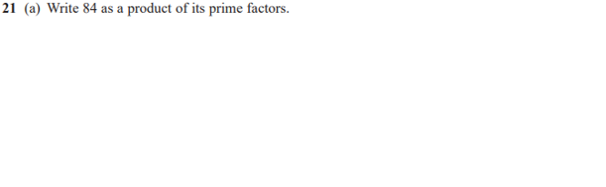
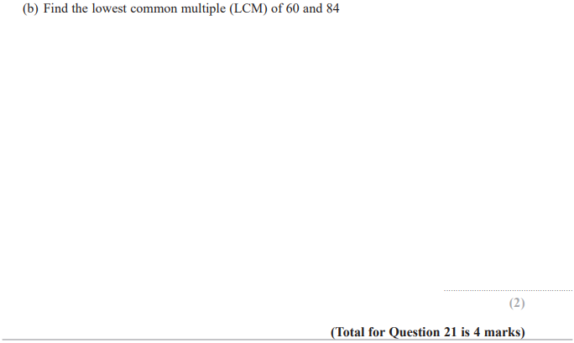

Pearson Edexcel - Tuesday 21 May 2019 - Paper 1 (Non-Calculator) Foundation Tier

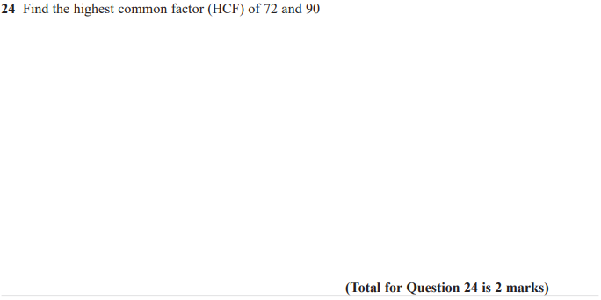

Pearson Edexcel - Thursday 7 June 2018 - Paper 2 (Calculator) Foundation Tier

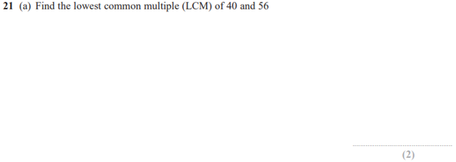
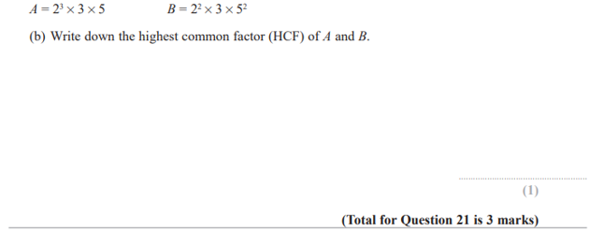

Pearson Edexcel - Thursday 2 November 2017 - Paper 1 (Non-Calculator) Foundation Tier

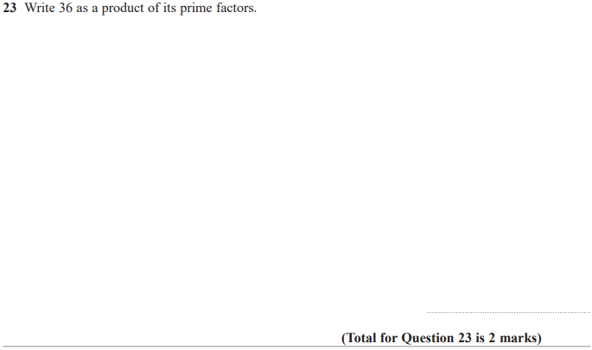

Pearson Edexcel – Specimen 2 - Paper 1 (Non-Calculator) Foundation Tier

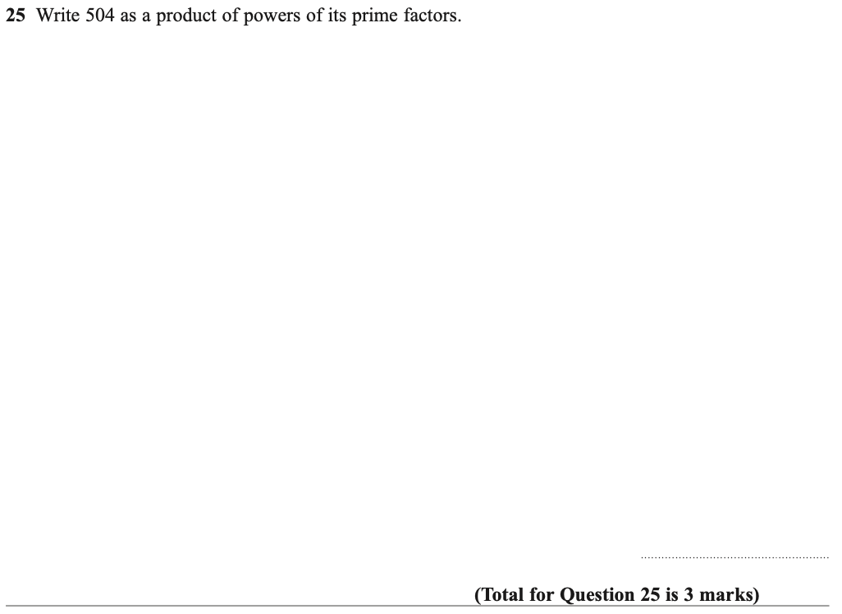

Pearson Edexcel – Specimen 2 - Paper 2 (Calculator) Foundation Tier

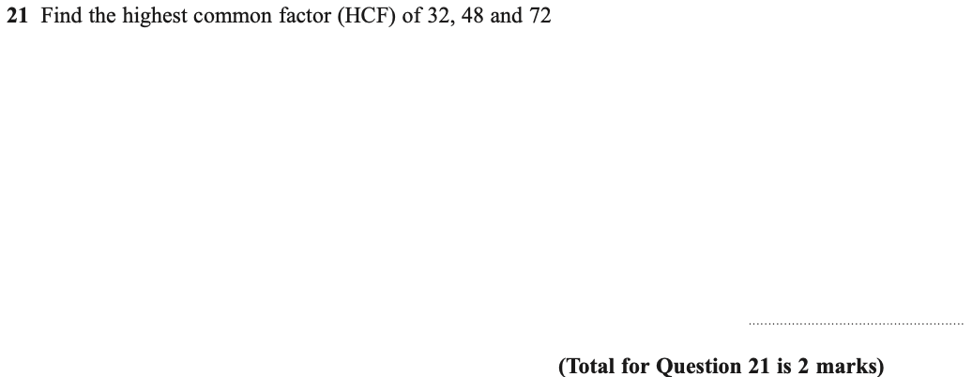

OCR Tuesday 11 June 2019 – Morning (Calculator) Foundation Tier
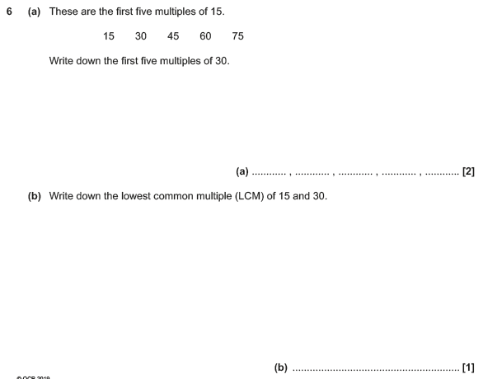

OCR Tuesday 6 November 2018 – Morning (Calculator) Foundation Tier

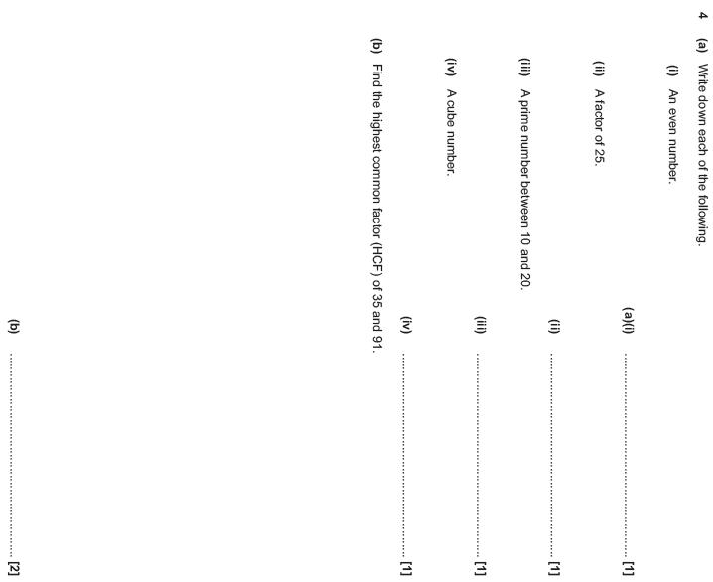

OCR Monday 24 May 2018 – Morning (Calculator) Foundation Tier
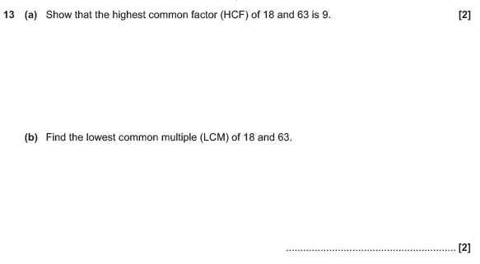

OCR Thursday 2 November 2017– Morning (Calculator) Foundation Tier
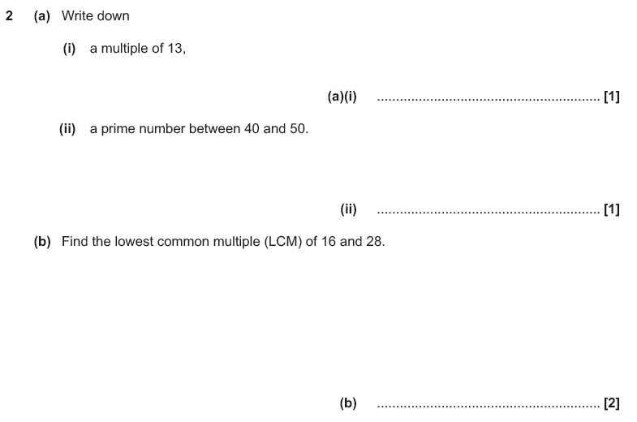

Pearson Edexcel –Sample Papers - Paper 2 (Calculator) Foundation Tier

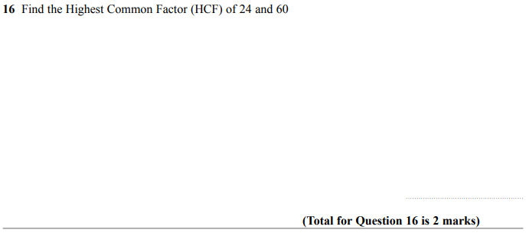

OCR Thursday 25 May 2017 – Morning (Calculator) Foundation Tier

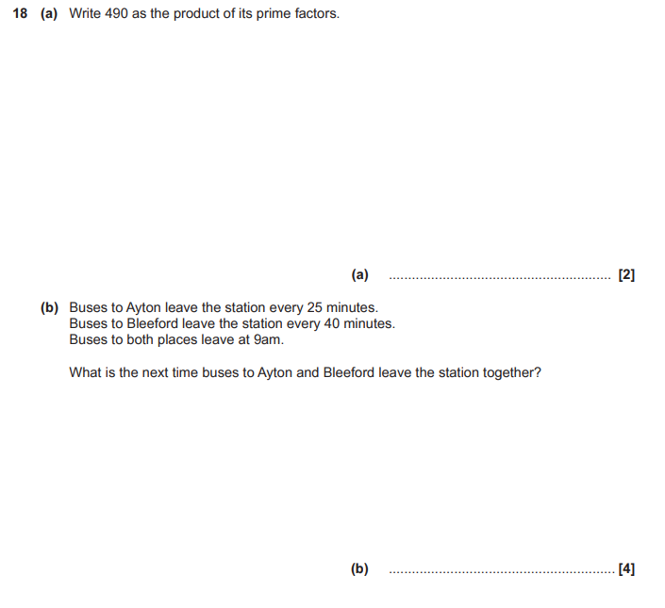

OCR Tuesday 13 June 2017 – Morning (Calculator) Foundation Tier

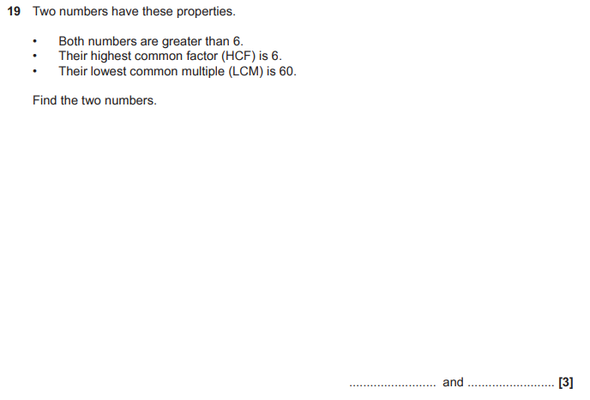

AQA Thursday 4 June 2020 – Morning (Calculator) Foundation Tier

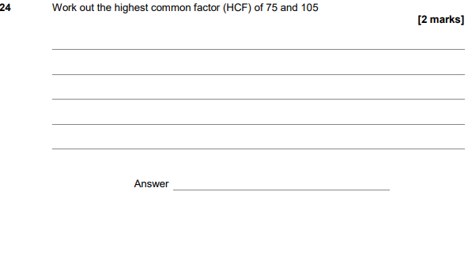
AQA Tuesday 21 May 2019 – Morning (Non-Calculator) Foundation Tier

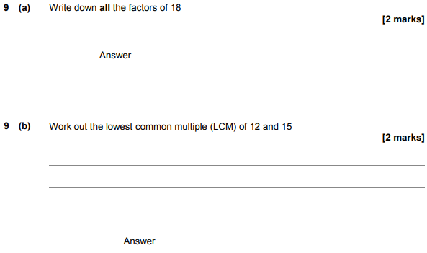

AQA Thursday 25 May 2017– Morning (Non-Calculator) Foundation Tier

